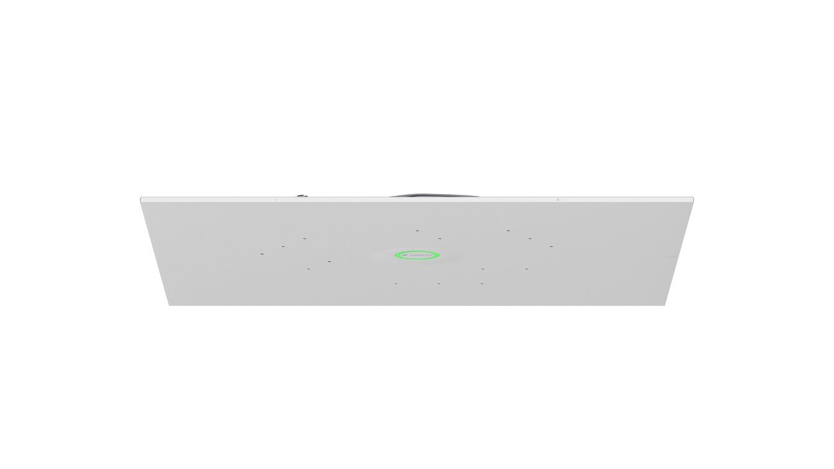

Sennheiser Announces the TeamConnect Ceiling Medium Ceiling Tile
New installation option unveiled at ISE 2025

Barcelona, Spain – February 4, 2025 – Sennheiser, the first choice for advanced audio technology that makes collaboration and learning easier, is excited to announce a new installation variant for its TeamConnect Ceiling Medium (TCC M) - the TeamConnect Ceiling Medium Ceiling Tile (TCC M CT) - which will be unveiled for the first time at Integrated Systems Europe (ISE) 2025 at booths 3B500 and 3B550 at the
Fira Barcelona Gran Via in Barcelona, Spain on February 4 - 7.

The TCC M CT allows for even easier installation of the TCC M into suspended grid ceilings, thereby reducing installation time and costs for integrators on site. The tile comes in a 60 cm square solution and a 2 ft square solution, primarily for the US market.

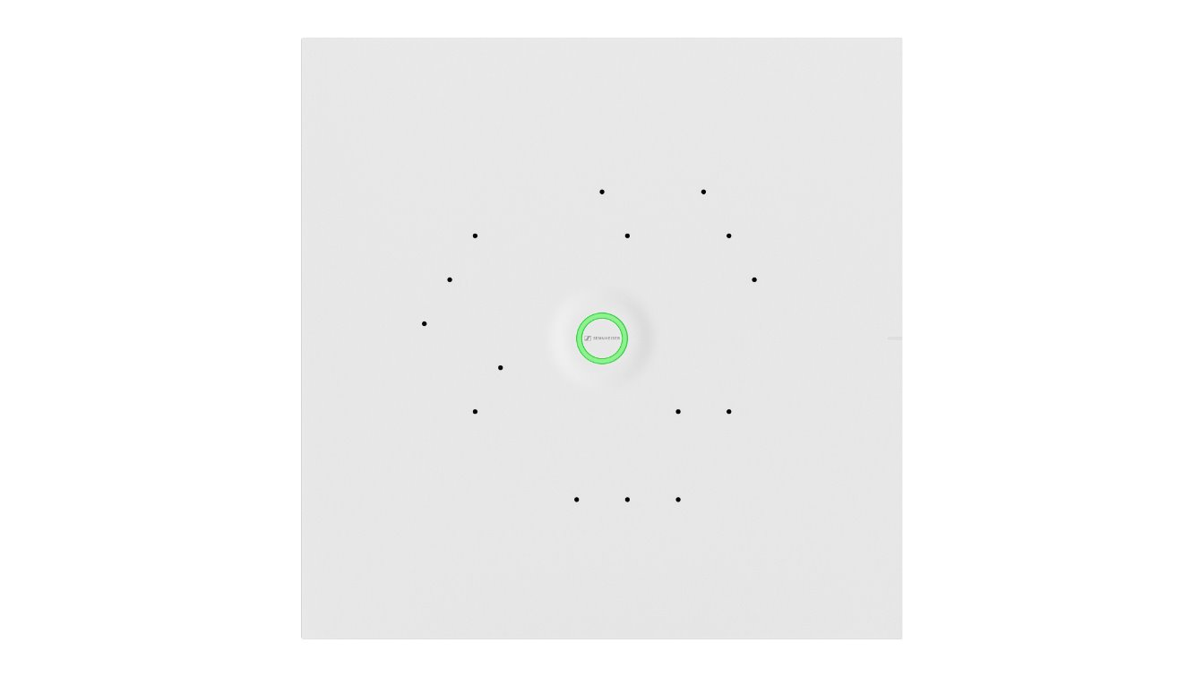

The new ceiling tile rounds out the TCC Solutions offering. Its sleek design blends into any environment making the TCC M the most versatile ceiling solution to fit every space. TCC M CT will be available as an assembled kit including a TCC M, front plate and safety ropes. For retrofit installations, the front plate can be ordered as an accessory.

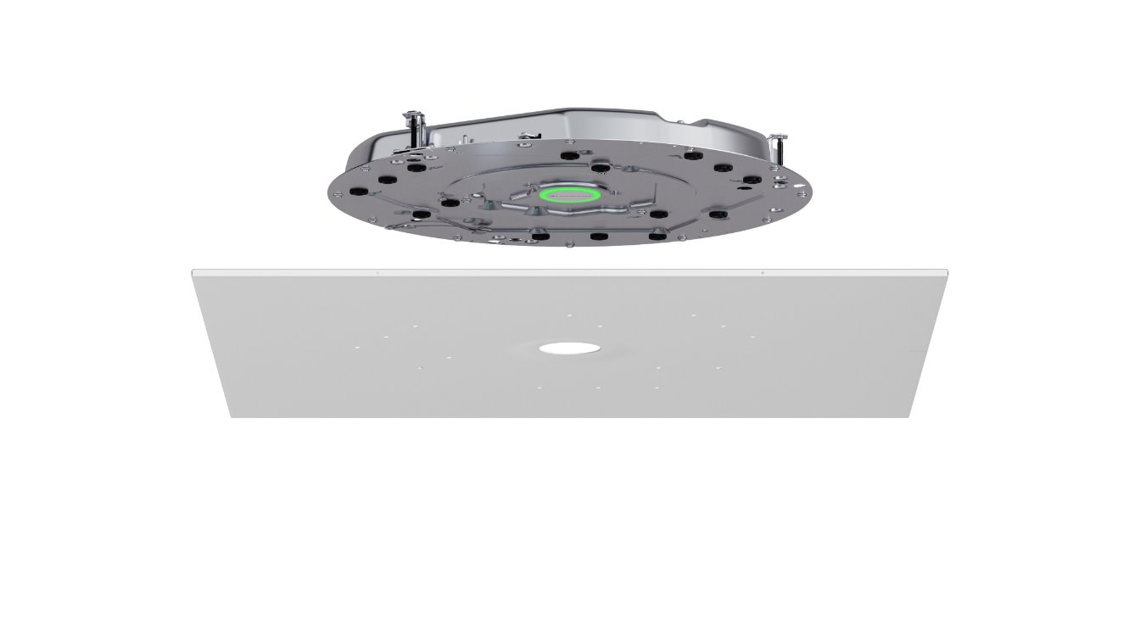
The TCC M allows integrators the versatility to offer elevated meeting experiences across a range of flexible and hybrid meeting spaces and learning environments. With its adaptive, intelligent beamforming technology, the TCC M ensures Trusted Sennheiser Audio Quality every time. Seamless integration with single cable mode and numerous design and installation options ensure TCC M transforms any room into a hub of collaboration.

The new TCC M CT will be sold as an assembled kit at the same dealer and retail prices as current TCC M flush and surface mounted kit options for every region. General availability is expected in Q2 2025.

More information about TCC M and the new TCC M CT can be found here.

About the Sennheiser brand
We live and breathe audio. We are driven by the passion to create audio solutions that make a difference. Building the future of audio and bringing remarkable sound experiences to our customers – this is what the Sennheiser brand has represented for more than 75 years. While professional audio solutions such as microphones, meeting solutions, streaming technologies and monitoring systems are part of the business of Sennheiser electronic GmbH & Co. KG, the business with consumer devices such as headphones, soundbars and speech-enhanced hearables is operated by Sonova Holding AG under the license of Sennheiser.

www.sennheiser.com
www.sennheiser-hearing.com

Global Press Contact
Jeff Horan
+1 860-598-7539
jeffrey.horan@sennheiser.com

